**Anoop Pai CS6740-Network Security**

**PS1**

**Internetworking**

Below is the sequence of steps followed when the browsers hits <http://www.northeastern.edu>:

1. As seen in the screenshot below, ARP request is broadcasted to all the servers. This gives the MAC address of 192.168.0.17 for the given client 192.168.0.1

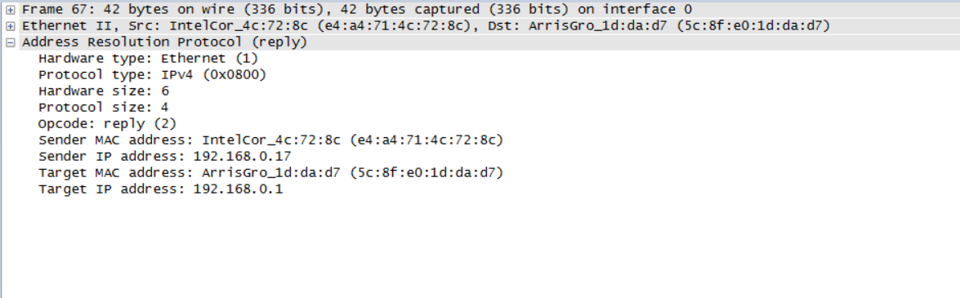

1. In this step, client address 192.168.0.17:52446 sends the request to the DNS server at 208.59.247.45:53 in order to obtain the IP address of www.northeastern.edu

C:\Users\anpsp\OneDrive\Pictures\Screenshots\dns(2)(2).PNG

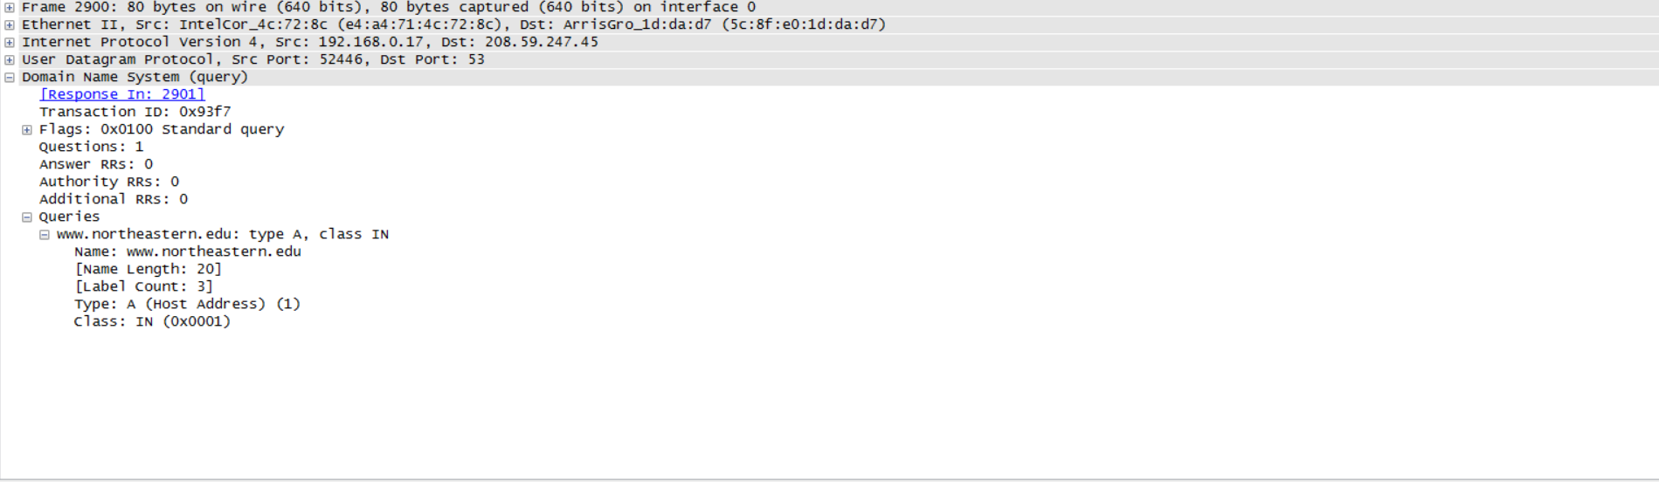

1. In this step, client address 192.168.0.17:52446 receives the response from the DNS server which includes the IP address of the website requested.

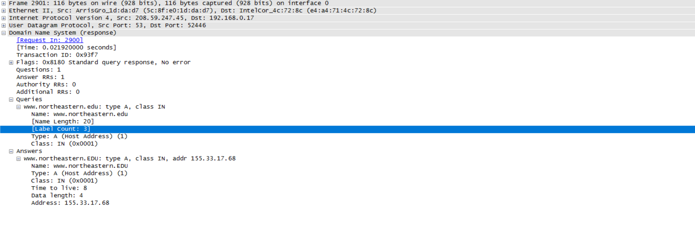

IP address of [www.northeastern.edu](http://www.northeastern.edu) = 155.33.17.68

Ethernet address of the client and the server:

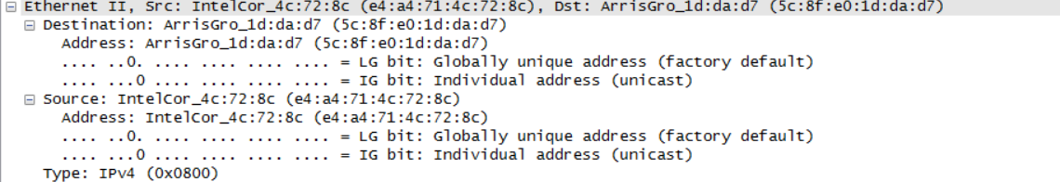

1. The below screenshot shows a TCP handshake taking place between 192.168.0.17:6374 and 155.33.17.68:80 which begins a SYN being sent from client to server, client gets back a SYN + ACK. And finally, the client sends an ACK back to server.



1. In this step, the client makes a HTTP request to the server which is responsible for serving the web page. During this process, the connection is ‘keep alive’ as indicated below.

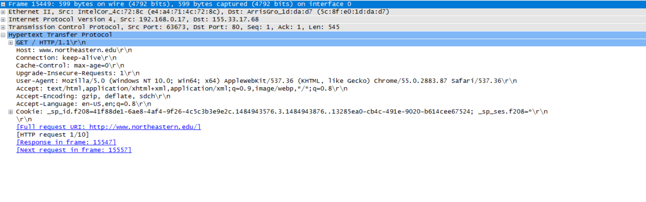

1. Once a TCP handshake has been established and a HTTP request has been made, it is clear below that the client receives TCP segments.

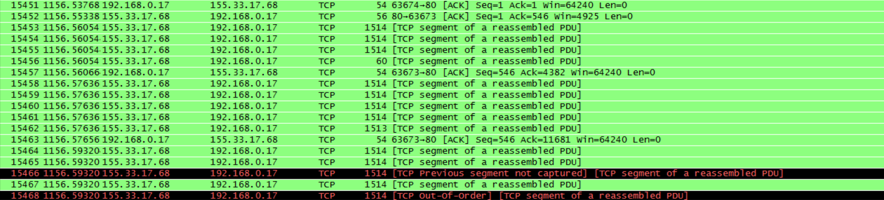

1. The client receives the 200 OK response from server, based on the request that was made in the previous step.

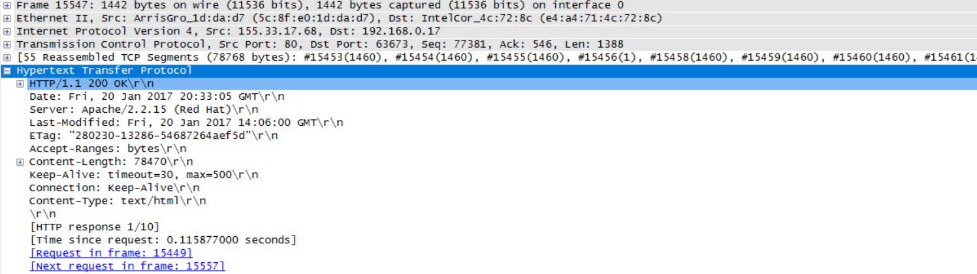

1. Finally, the webpage is rendered by the browser after fulfilling every HTTP GET request made by the client to the server as per requirement.

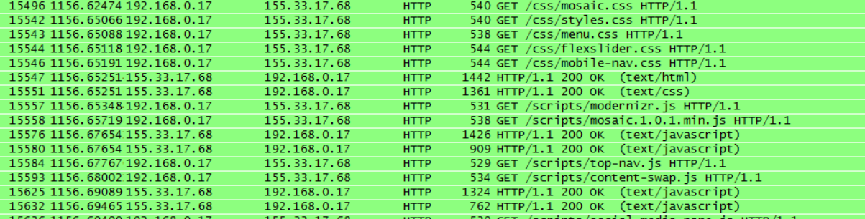

Network Stack is as below:

